STA2023 – Statistical Methods I
Instructor: Amir Alipour Yengejeh
Chapter 2. Organizing and Summarizing Data
Table of Contents
2.1 Organizing Qualitative Data 2
Tables 2
Qualitative Graphs 4
2.2 Organizing Quantitative Data: The Popular Displays 9
Histograms 9
Describing the Shape of Distributions 12
2.3 Additional Displays of Quantitative Data 14
2.4 Graphical Misrepresentations of Data 16

Learning Objections: By the end of this chapter, students should be able to:
- Organize qualitative data into table.
- Read and interpret bar charts and pie charts.
- Organize quantitative data into table.
- Read, interpret, and describe histograms.
- Read and interpret other graph types, such as stem-and-leaf plots.
- Identify when a graph is misleading, and how to fix it.

2.1 Organizing Qualitative Data
When data is collected from a survey or designed experiment, they must be organized into a manageable form. Data that is not organized is referred to as raw data.

Ways to Organize Data:
- Tables
- Graphs
- Numerical Summaries (Chapter 3)

Chapter 2 focuses on tables and graphs. Depending on the type of data we have, we use different methods to summarize and organize data. First, we’ll look at tables.

Tables

Definition: A frequency distribution

Definition: The relative frequency

A relative frequency distribution

Example 1: A survey was conducted by Slashdot (www.slashdot.org) in which individuals were asked, “What is the best day of the week, generally?”. The following results are based on the 40 people who answered the survey. Construct a frequency distribution and relative frequency distribution of day of the week.

Thursday | Friday | Saturday | Friday | Saturday
Friday | Friday | Sunday | Friday | Saturday
Monday | Saturday | Saturday | Friday | Saturday
Saturday | Friday | Thursday | Saturday | Tuesday
Friday | Thursday | Tuesday | Wednesday | Saturday
Monday | Saturday | Saturday | Sunday | Saturday
Sunday | Thursday | Saturday | Saturday | Friday
Friday | Sunday | Sunday | Saturday | Wednesday

SOLUTION:

Day of the Week | Frequency | Relative Frequency
Sunday | 5
Monday | 2
Tuesday | 2
Wednesday | 2
Thursday | 4
Friday | 10
Saturday |  | 0.375
Total | 40 | 1.000

Example 2: A physical therapist wants to determine the types of rehabilitation required by her patients. To do so, she obtains a simple random sample of 30 of her patients and records the body part requiring rehabilitation. See the frequency distribution of location of injury below. Fill out the distribution below.

Body Part | Frequency | Relative Frequency
Back | 12
Wrist |  | 0.0667
Elbow |  | 0.0333
Hip |  | 0.0667
Shoulder |  | 0.1333
Knee |  | 0.1667
Hand |  | 0.0667
Groin |  | 0.0333
Neck | 1
Total | 30 | 1.0000

Qualitative Graphs
Once raw data are organized in a table, we can create graphs. Just as “a picture is worth a thousand words,” pictures of data result in a more powerful message than tables.

Definition: A bar graph is constructed by labeling each category on either the horizontal or vertical axis and frequency or relative frequency on the other axis.

Example 3: Type of Rehabilitation
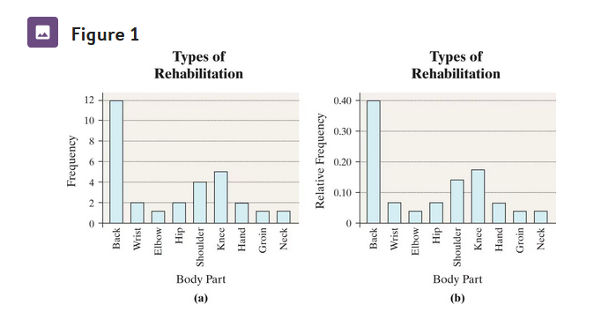
Notes:
- Graphs should always start from 0, have bars of equal width, and be two-dimensional.
- Graphs that don’t start from 0, have unequal bar widths, or are three-dimensional are considered misleading and should not be used.

Definition: A Pareto chart

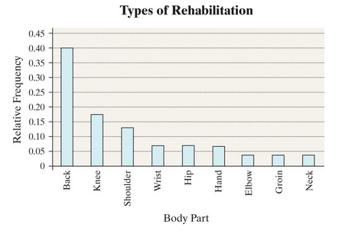
Comparing Two Data Sets
The data in Table 4 represent the educational attainment in 1990 and 2021 of adults 25 years and older who are residents of the United States. The data are in thousands, so 39,344 represents 39,344,000.
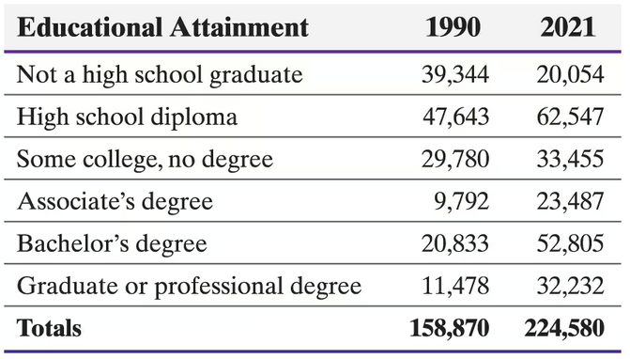

- When comparing two datasets, you should always use relative frequency. The two datasets you are comparing will likely have different population sizes, making comparisons of frequencies difficult or misleading.
- The relative frequency distributions are shown below for these datasets:

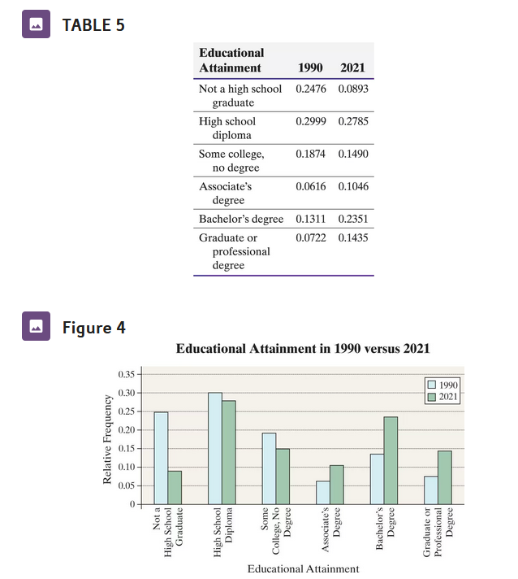



What conclusions can we make about educational attainment?

Definition: A pie chart is a circle divided into sectors.

Example 4: Refer to the educational attainment example.
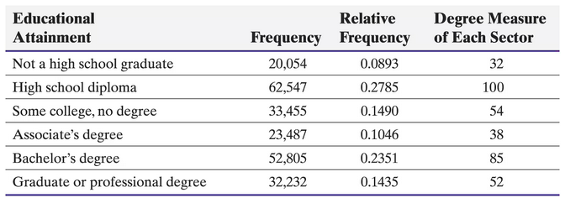
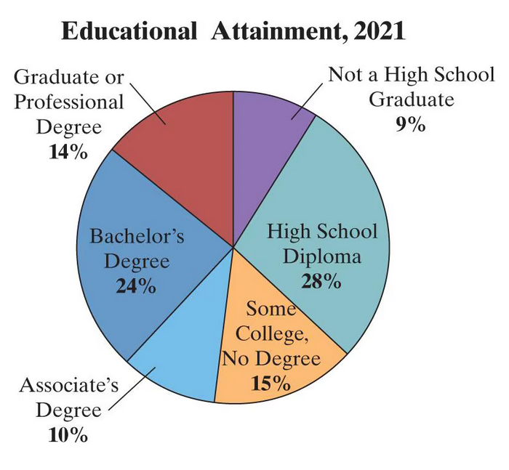
- True/False: More than 50% of Americans have some college experience (some college, no degree or higher).
- About what percentage of Americans have a high school diploma or below (not a high school graduate)?

When to use a pie chart vs. bar chart:
- Generally, if you care more about showing parts of a whole, then pie charts are more useful. However, if you want to compare more two specific values, the angles of pie charts are sometimes difficult to judge by eye and bar charts are more useful.
- Also, if you want to compare just a few categories (for example, just those who have any level of college degree), then you would have to use a bar chart.

2.2 Organizing Quantitative Data: The Popular Displays

Histograms
Now, suppose our data is quantitative. How do we summarize numeric data in tables and graphs? We select certain ranges and count the number of observations within certain ranges. These ranges are called classes, formally defined below:

Definition: Classes are

The table below represents data from a simple random sample of 50 parking and camera violations in the City of New York.
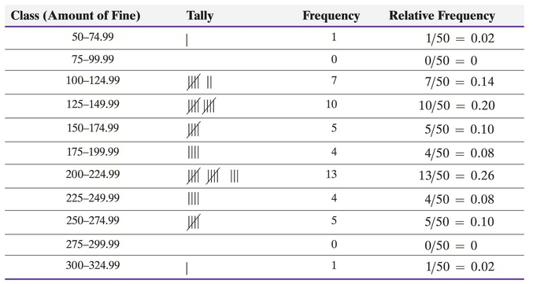
Lower class limits are

Upper class limits are

Class width is
Notes:
- The data in the table above is continuous. The class 50 – 74.99 actually represents 50 – 74.999999…, or 50 up to anything less than 75.
- Classes do not overlap. Class widths are equal for all classes.
  - The only exception is with open-ended tables. Tables are open-ended if the first class has no lower class limit (for example < $75) or if the last class has no upper class limit (for example, $300 or more).

A frequency histogram is

A relative frequency histogram

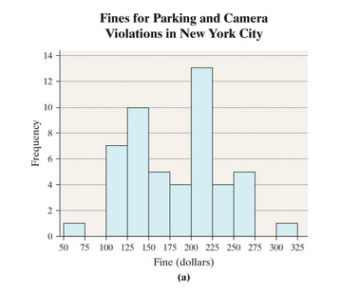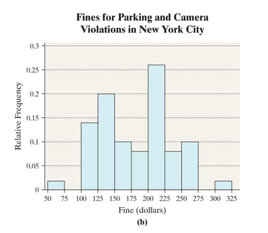

Example 5: The following data comes from the U.S. News and World Report from 1995 showing the graduation rates of various universities in the US.

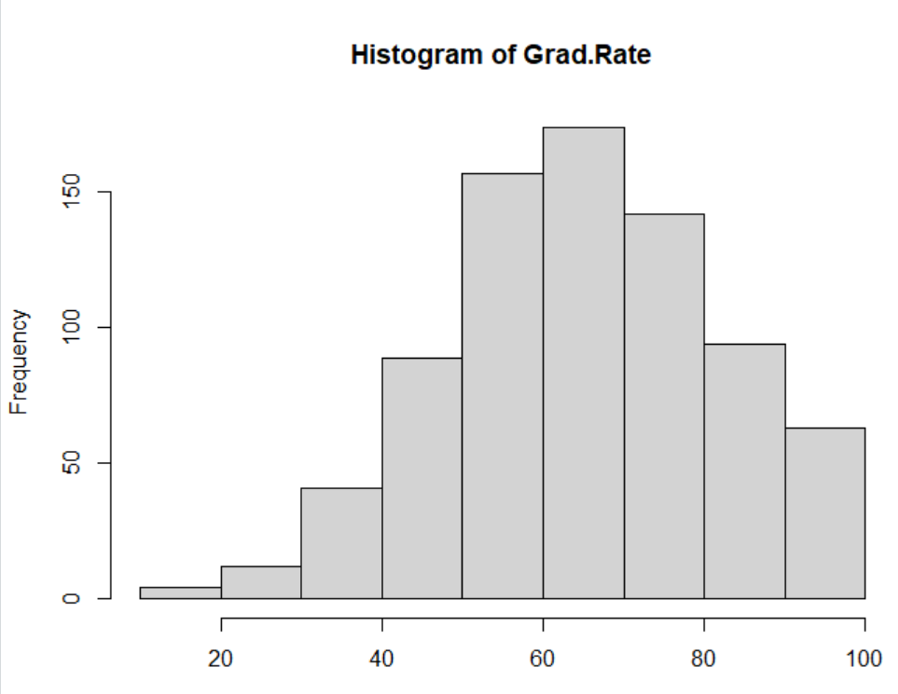
- Is this a frequency histogram or a relative frequency histogram?

- What is the class width?

- What is the most frequent class?

- Approximately how many universities had a graduation rate between 90% and 100%?

Describing the Shape of Distributions
Generally, we try to describe distribution by the shape of it.
- Distributions are symmetric when if they are split down the middle, the left and right sides are almost mirror images.
- Two kinds of symmetric distributions are uniform distributions and bell-shaped distributions.

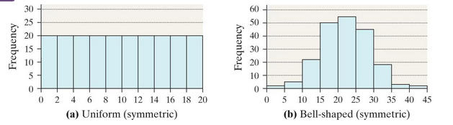

- If a distribution is not symmetric, we describe it as skewed. The direction of the tail is the direction of the skew.
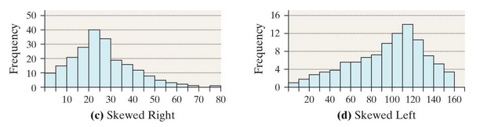

Example 6: Recall that the U.S. News and World Report from 1995 showing the graduation rates of various universities in the US. Other variables include were number of students accepted, percentage of faculty with a PhD, and cost of room and board. Describe the shape of each histogram.

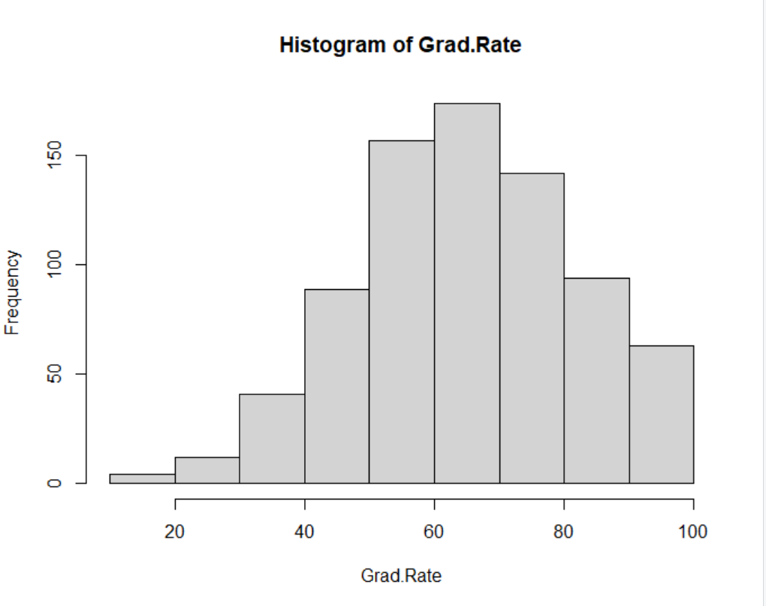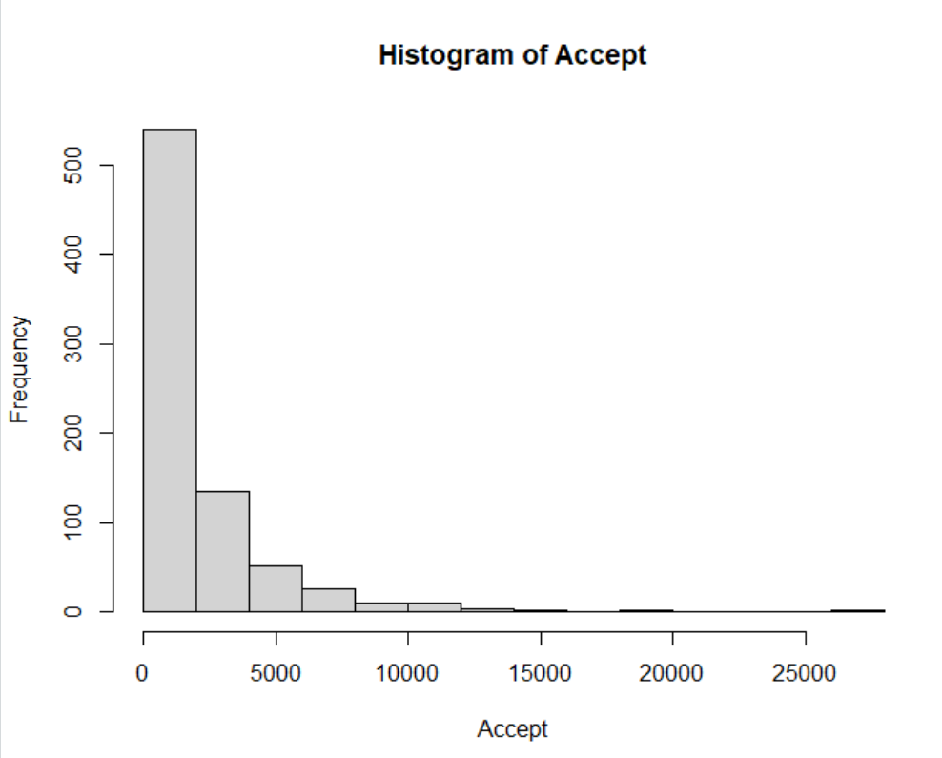
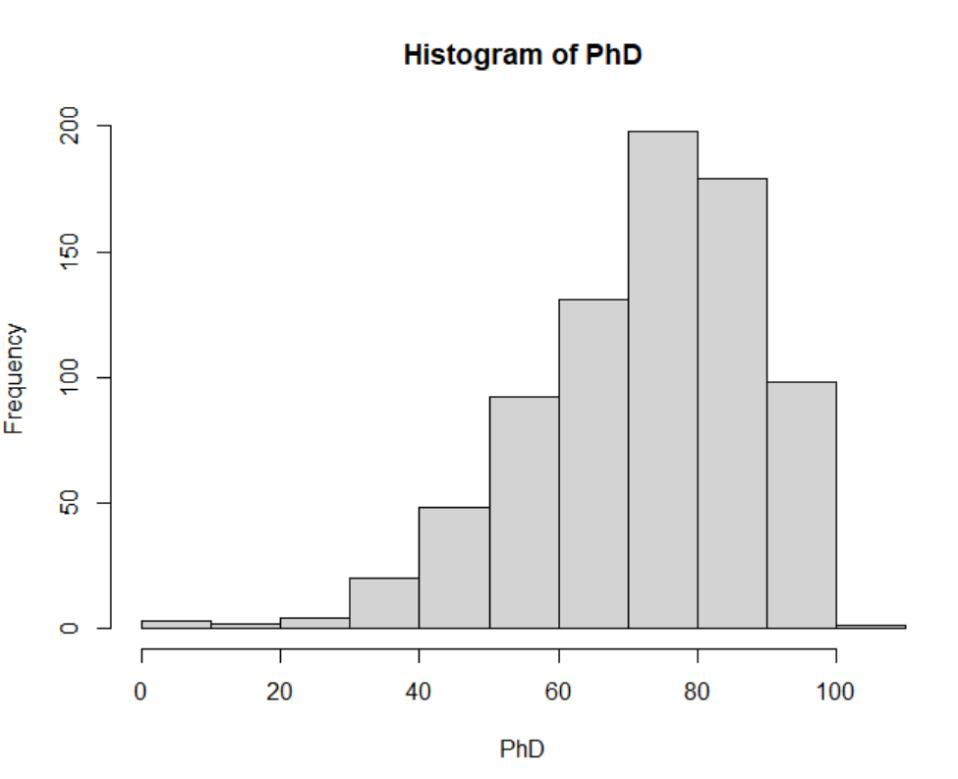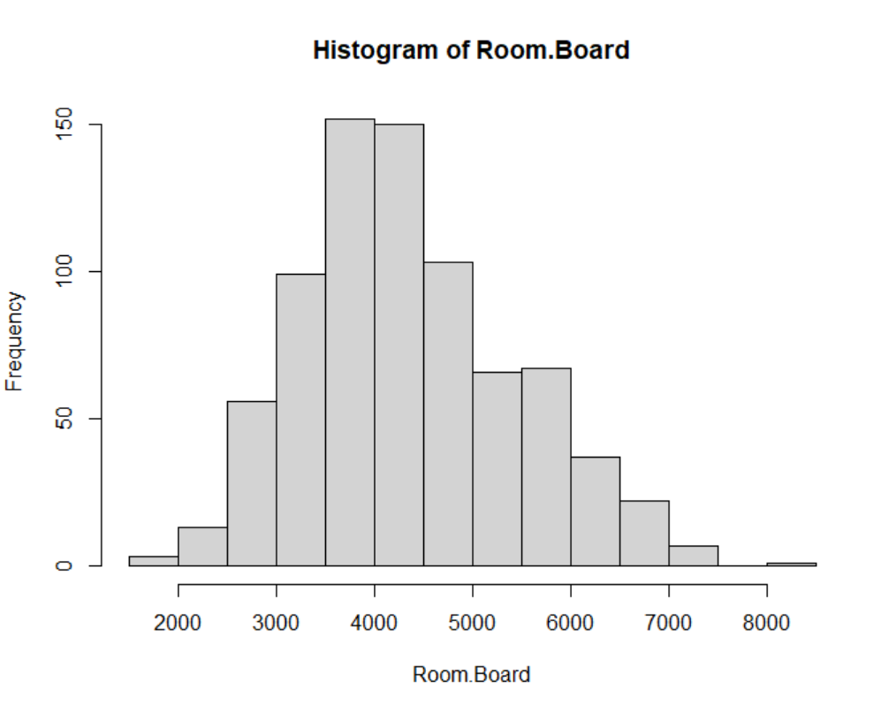

2.3 Additional Displays of Quantitative Data
There are two additional types of graphs we will go over:
- Stem-and-leaf plots
- Time-Series Graphs

Definition: A stem-and-leaf plot

Stem and plots are rarely used, but I am under obligation to teach it to you. Consider the exam scores of a small class:
56 | 60 | 66 | 68 | 80 | 82 | 82
84 | 88 | 90 | 92 | 94 | 98 | 98

Definition: A time-series plot is obtained by plotting the time in which a variable is measured on the horizontal axis and the corresponding value of the variable on the vertical axis. Line segments are then drawn connecting the points.

Example 7: The Partisan Conflict Index (PCI) tracks the degree of political disagreement among U.S. politicians in the federal government. It is found by measuring the frequency of newspaper articles reporting disagreement in a given month. Higher values of the index suggest greater conflict among political parties, Congress, and the President. The data in Table 18 represents the PCI in December from 2004 to 2022. Construct a time-series plot of the data. In what year was the index highest?
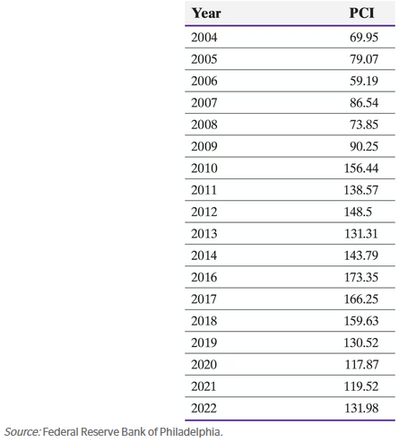

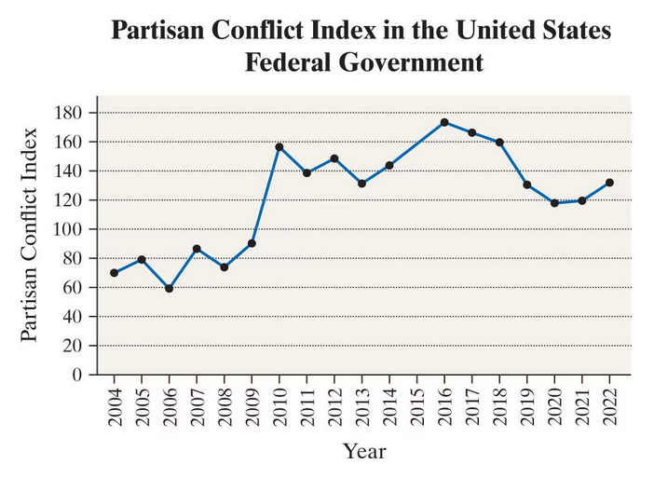

2.4 Graphical Misrepresentations of Data
“Statistics often gets a bad rap for having the ability to manipulate data to support any position. One method of distorting the truth is through graphics.” – Evan Esar
- Statistics often gets a bad rap for having the ability to manipulate data to support any position. One method of distorting the truth is through graphics.
- Generally, there are two ways that mislead (unintentionally) or deceive (intentionally) people:
  - Manipulating the vertical axis, such as not starting on 0.
  - Changing the width of the bars.

Example 8: A national news organization developed the graphic shown in Figure 22 to illustrate the change in the highest marginal tax rate effective January 1, 2018. Why might this graph be considered misleading?
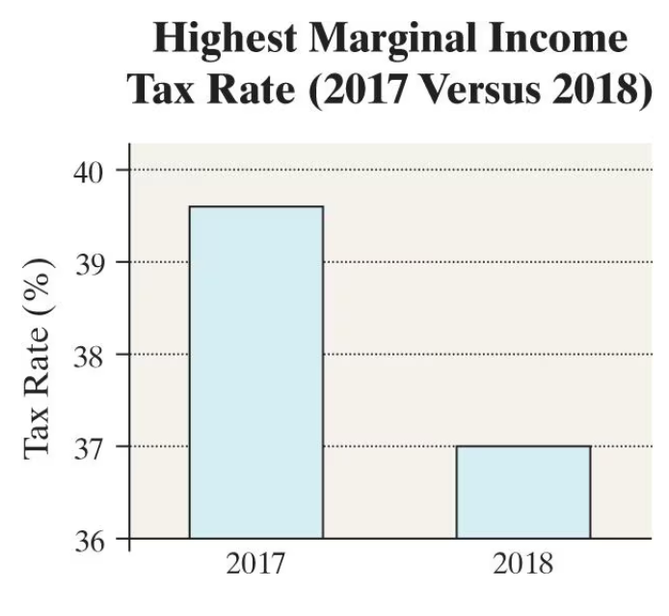

Example 9: The following shows the proportion of accidents on four major highways in a certain city. Which graph is misleading, and why is it misleading?

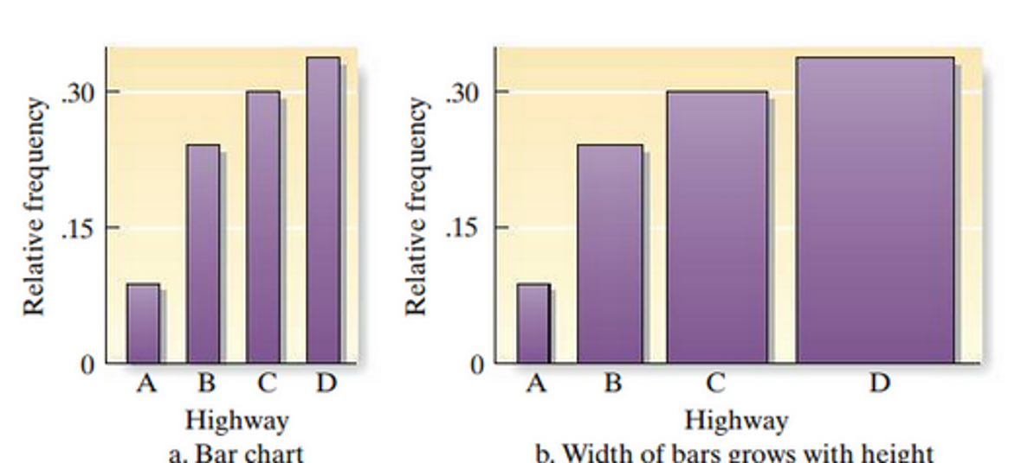

- There are many, many other ways to make poor graphics:
  - 3D plots (difficult to read)
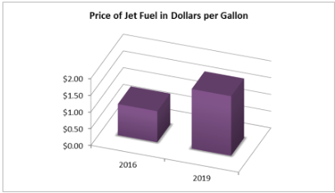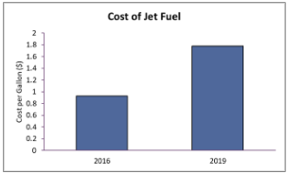
  - Inverting axes (higher on the y-axis means a lower value)
  - Unexpected colors (generally, darker means a higher concentration to most people).
